Question 1: Tokenization
The word "MISUNDERSTANDING" is uncommon enough that a sub-word tokenizer would likely split it into smaller pieces rather than keep it whole.
(a)
Split "MISUNDERSTANDING" into 3 reasonable sub-word pieces (there's no single "correct" answer – justify your split).
Answer:
MIS + UNDER + STANDING
Justification:
- MIS = prefix meaning "wrong" or "incorrect".
- UNDER = common English root.
- STANDING = common suffix/root forming the final meaning.
(b)
In 1–2 sentences, explain WHY sub-word tokenization (rather than whole-word tokenization) helps a model handle a word like this one, even if the model has never seen the whole word before in training.
Answer:
Sub-word tokenization allows the model to understand unfamiliar words by breaking them into meaningful smaller pieces. Even if the complete word has never appeared during training, the model already knows the meanings of the individual sub-words.

OUTPUT
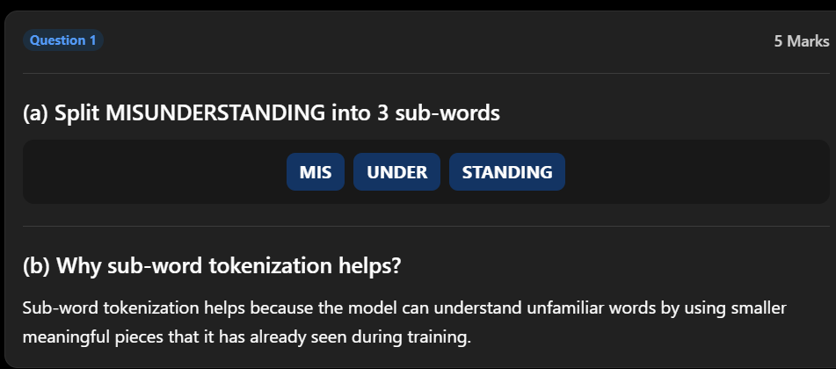
Question 2: Embeddings
Consider the word pairs:
- "happy" and "joyful"
- "happy" and "chair"
(a)
Which pair would you expect to have HIGHER cosine similarity in embedding space, and why?
Answer:
The pair happy – joyful has the higher cosine similarity because both words have similar meanings and are used in similar contexts. "Happy" and "chair" are unrelated, so their similarity is much lower.
(b)
In your own words, what does an embedding actually represent, and how is it different from a one-hot vector?
Answer:
An embedding is a dense numerical vector that captures the semantic meaning and relationships of a word. Unlike a one-hot vector, embeddings place similar words close together in vector space, allowing the model to understand similarity between words.
OUTPUT
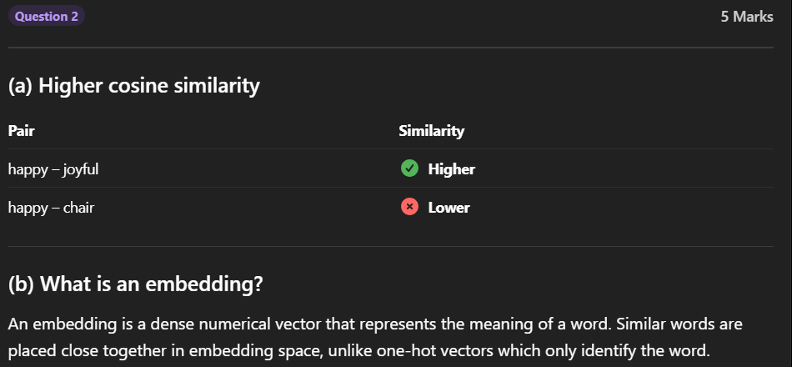

Question 3: Self-Attention Worked Example
Read the sentence:
"Sam tried to call George on the phone, but he wasn't successful."
(a)
The word "he" should attend most strongly to which other word in the sentence? Circle one:
- Sam
- George
Answer:
"Sam tried to call George on the phone, but he wasn't successful."
"He" refers to:
✔ Sam
(b)
Explain in 2–3 sentences WHY self-attention (not a simple word-order rule) is needed to correctly resolve what "he" refers to.
Answer:
Self-attention considers the meaning of the sentence rather than only word order. It understands that the group likely to fear violence is the city council, so it correctly links "they" to "city council."
OUTPUT
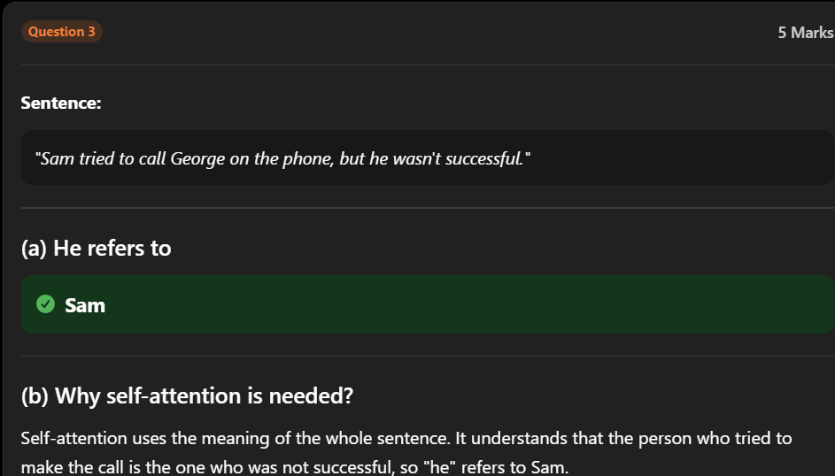
Question 4: Query, Key, Value (5 Marks)
In your own words, briefly explain what the Query, Key, and Value vectors each represent in self-attention, and how they combine to produce an attention score.
Answer:
- Query: What the current word wants to find.
- Key: Information used to determine whether another word is relevant.
- Value: The actual information passed from that word.
The Query is compared with all Keys to compute attention scores. The Values are then weighted according to these scores to generate the final contextual representation.
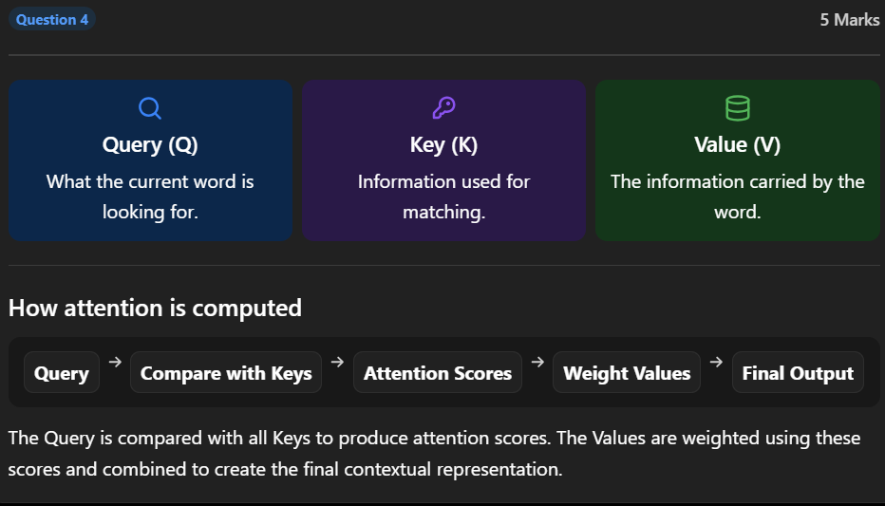

BY:
Hemanth p(192472285)

